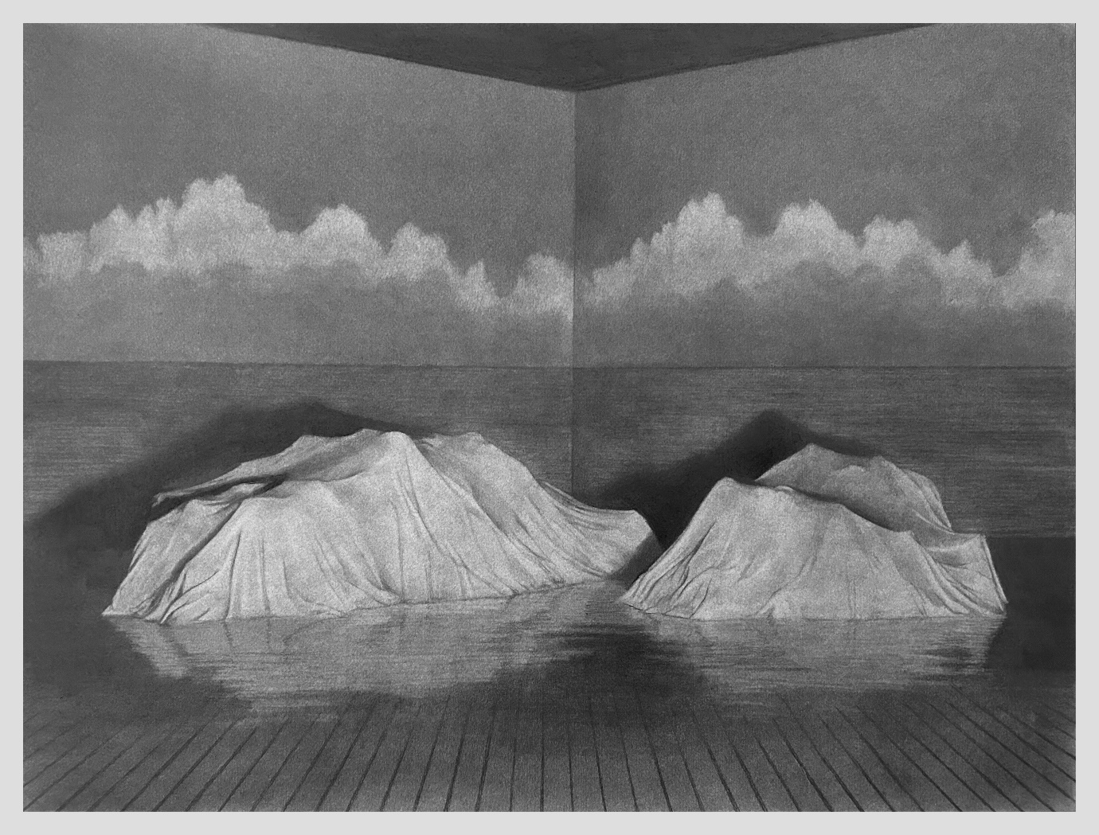  
  
Proscenium I  
Graphite and charcoal on paper  
18in x 24in   
2025

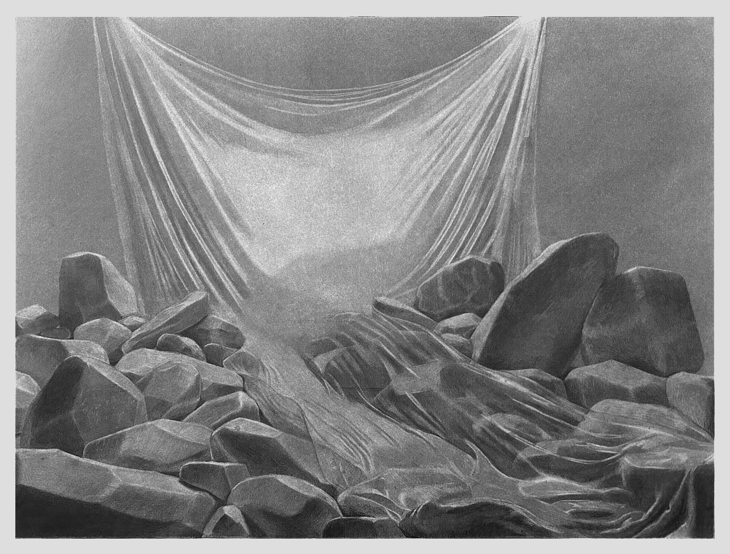  
  
Proscenium II  
Graphite and charcoal on paper  
18in x 24in   
2025

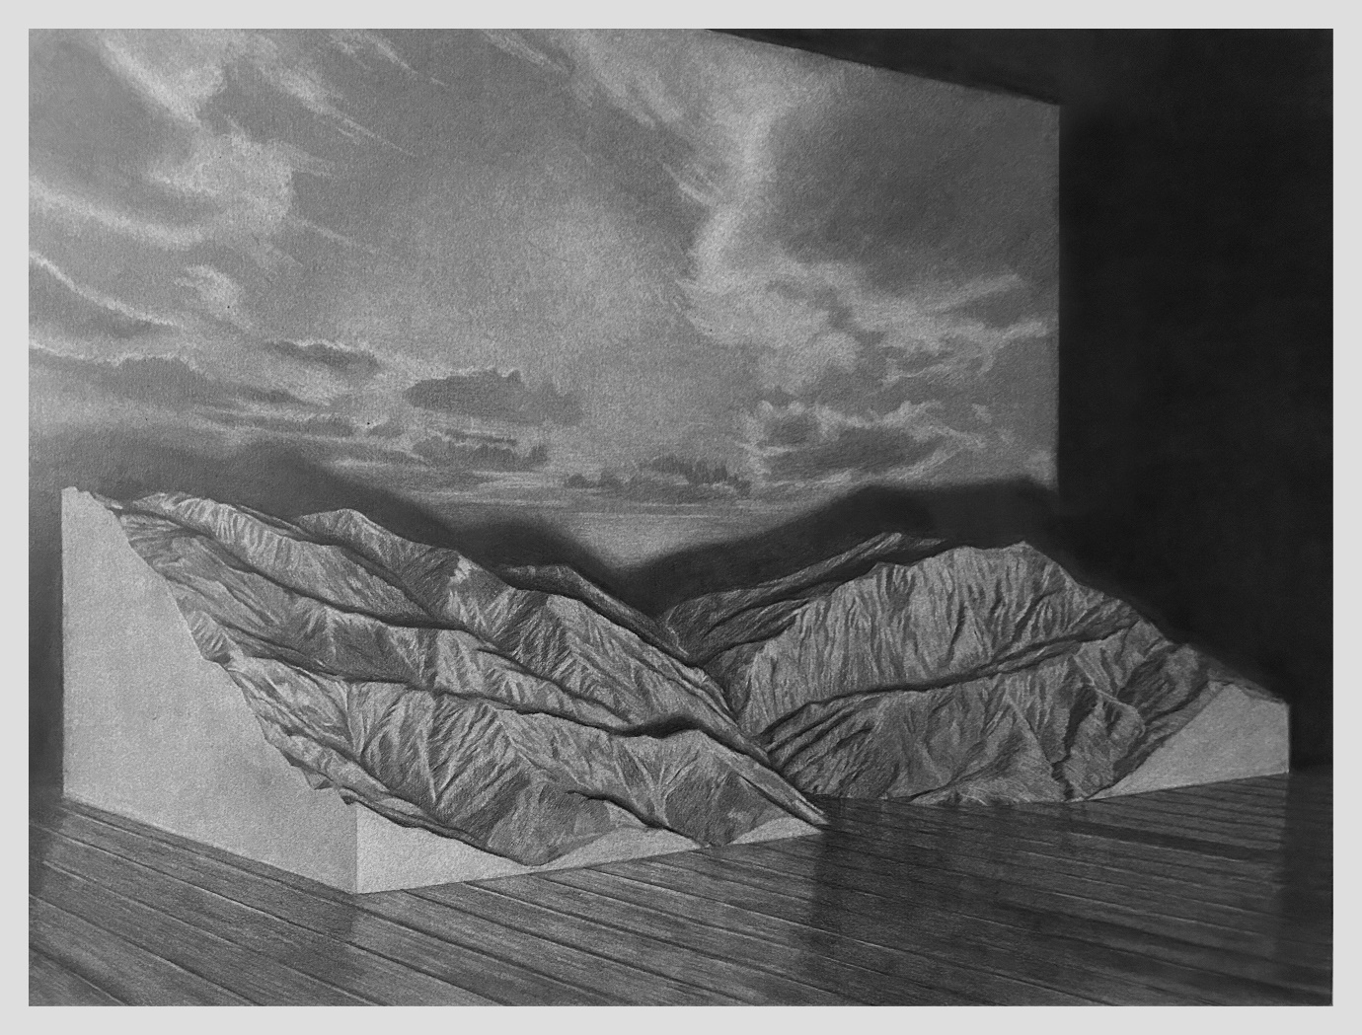  
  
Proscenium III  
Graphite and charcoal on paper  
18in x 24in   
2025

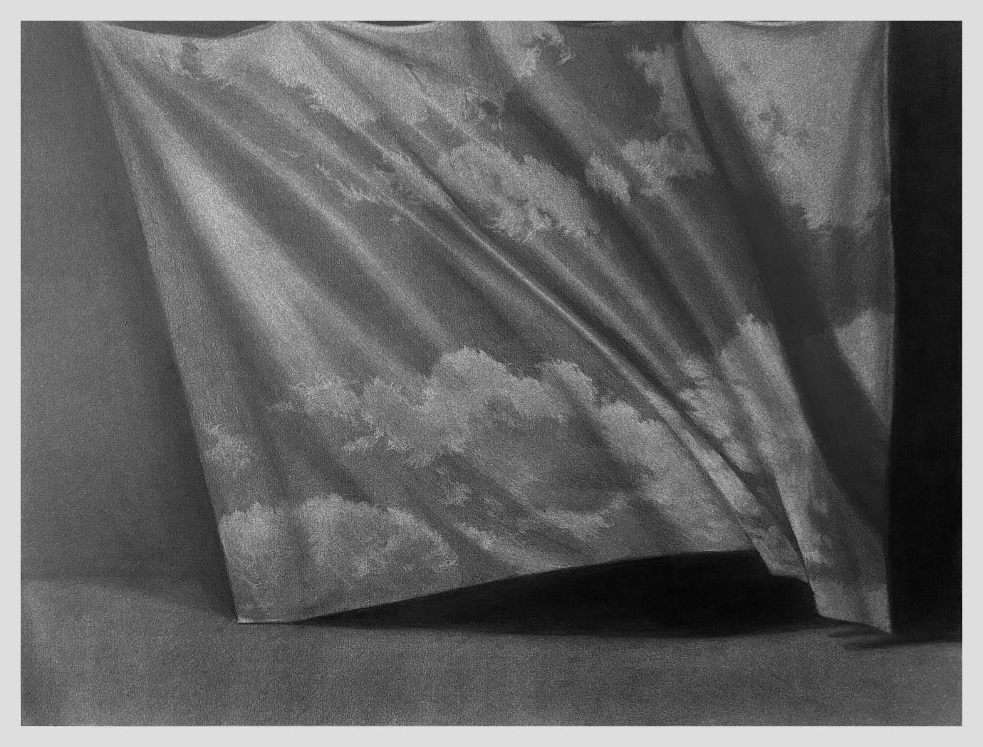  
  
Proscenium IV  
Graphite and charcoal on paper  
18in x 24in   
2025

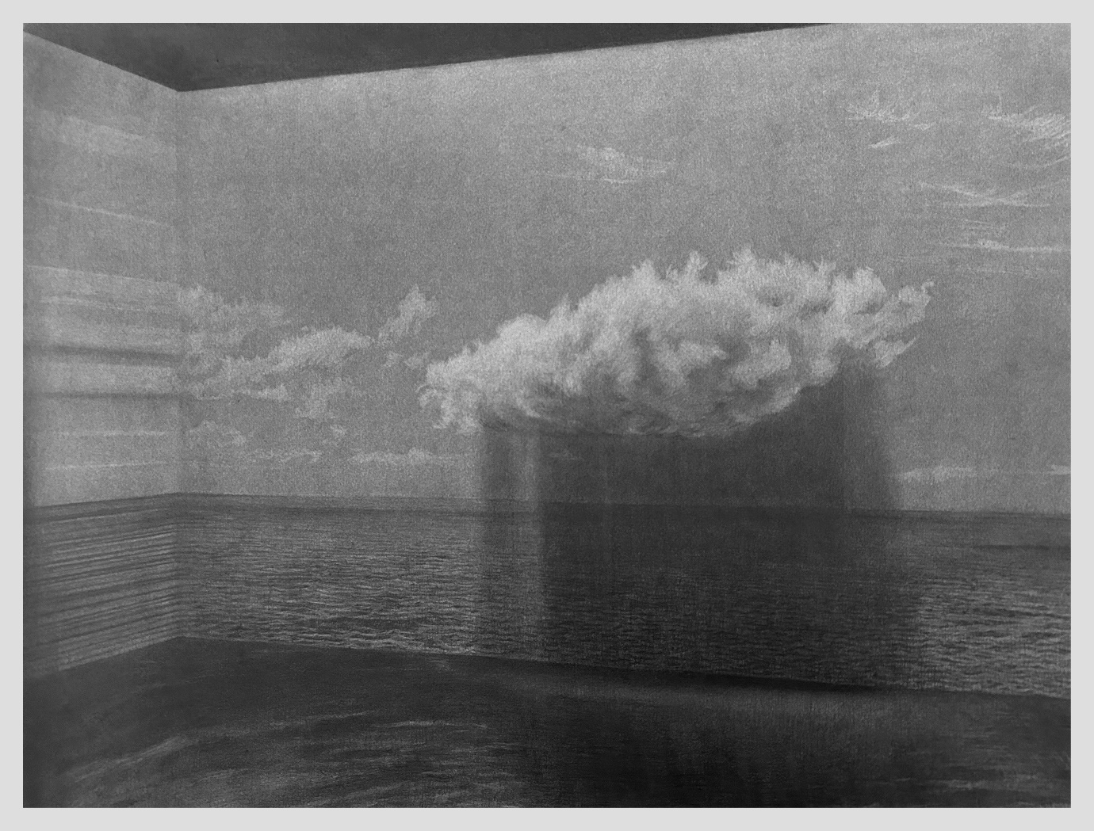  
  
Proscenium V  
Graphite and charcoal on paper  
18in x 24in   
2025

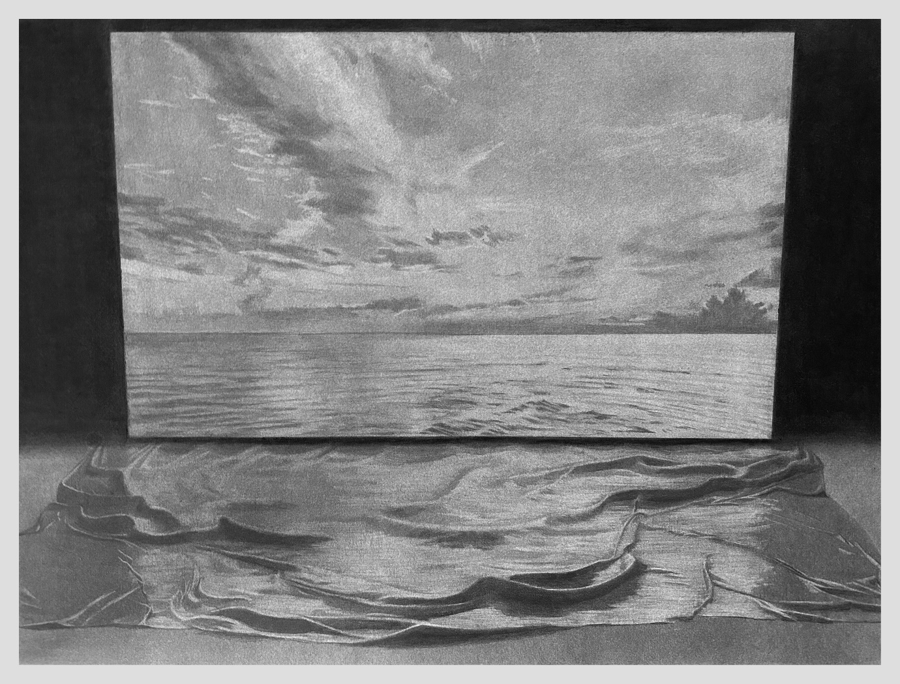

Proscenium VI  
Graphite and charcoal on paper  
18in x 24in   
2025

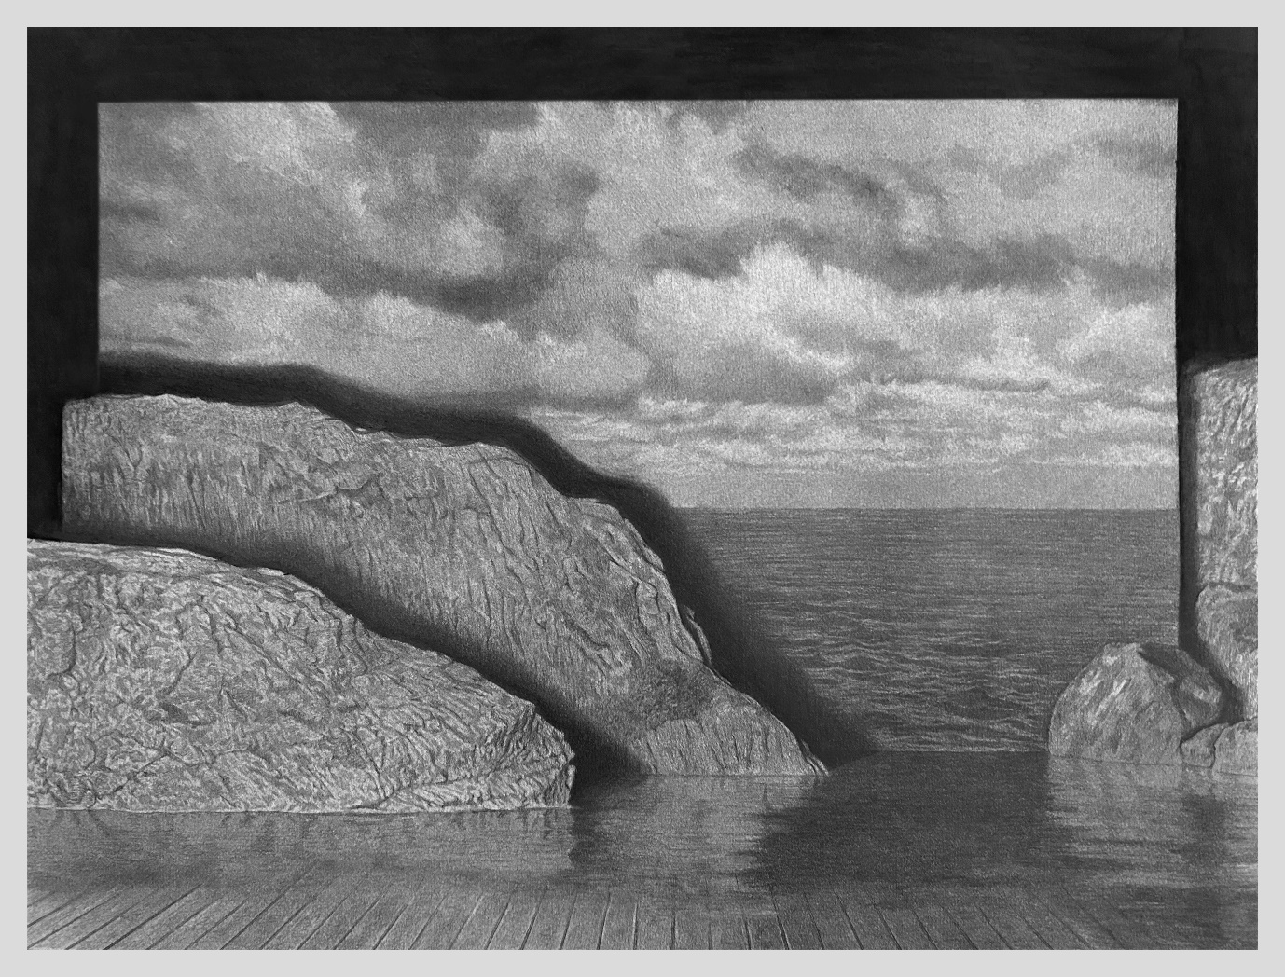

Proscenium VII  
Graphite and charcoal on paper  
18in x 24in   
2025

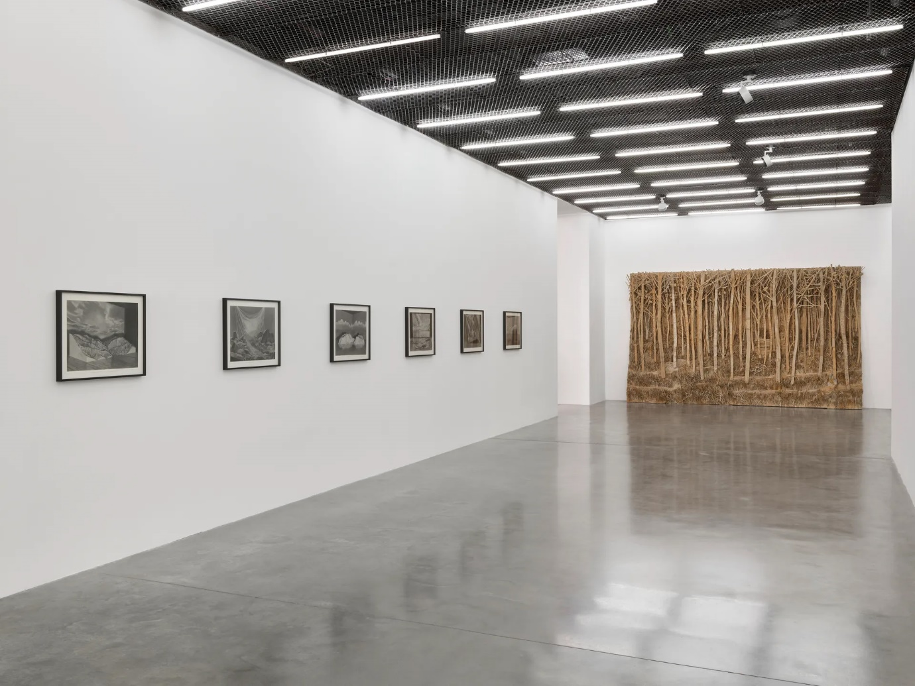

*[Alien Shores: landscape, once removed](https://www.whitecube.com/gallery-exhibitions/alien-shores-bermondsey-2025" \o "View Alien Shores, Bermondsey (2025))*[, White Cube, Bermondsey, 2025](https://www.whitecube.com/gallery-exhibitions/alien-shores-bermondsey-2025" \o "View Alien Shores, Bermondsey (2025))